Playdough Spring Tree

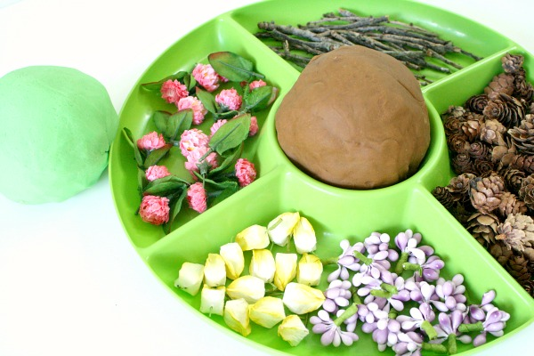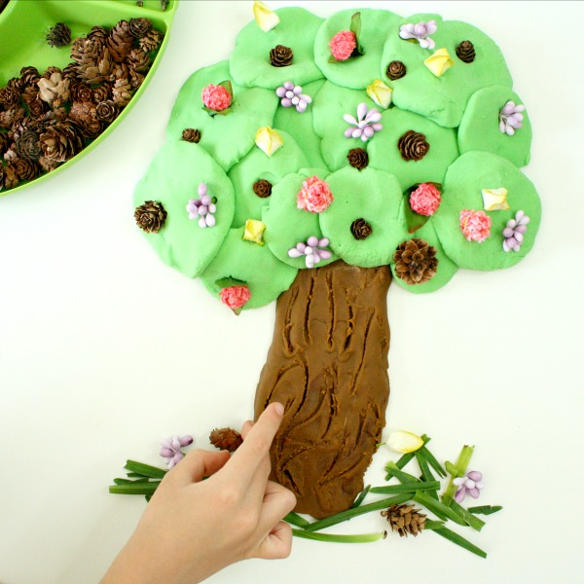

After you have been on your Spring Walk and gathered lots of signs of Spring, you can make your own playdough Spring tree. You will need green and brown playdough, follow our easy to make playdough recipe.

