Drama – Role Play

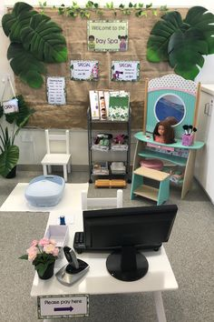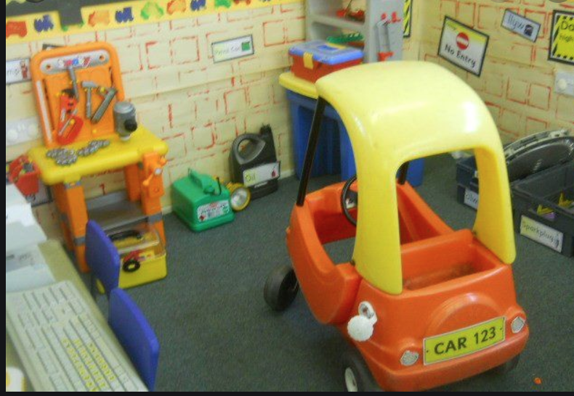

For most children make believe is one of their very favourite types of play. Extend this by creating role play scenarios in your home. Could you turn a corner into a beauty spa or a garage using props you have in your house?
Drama – Role Play

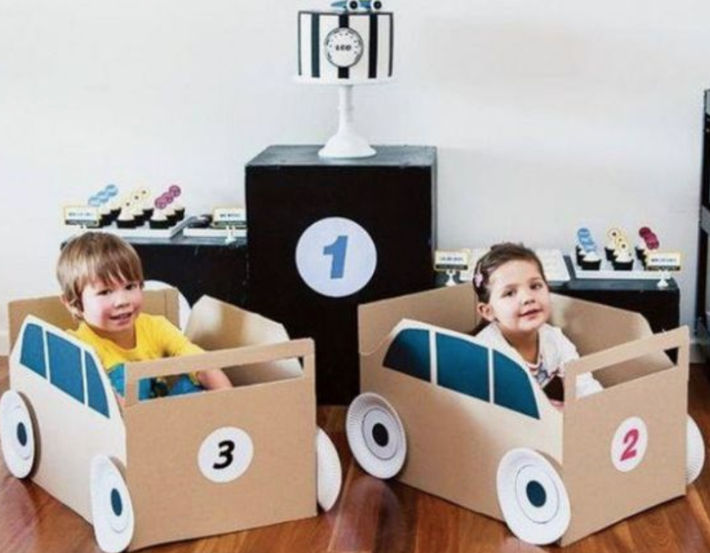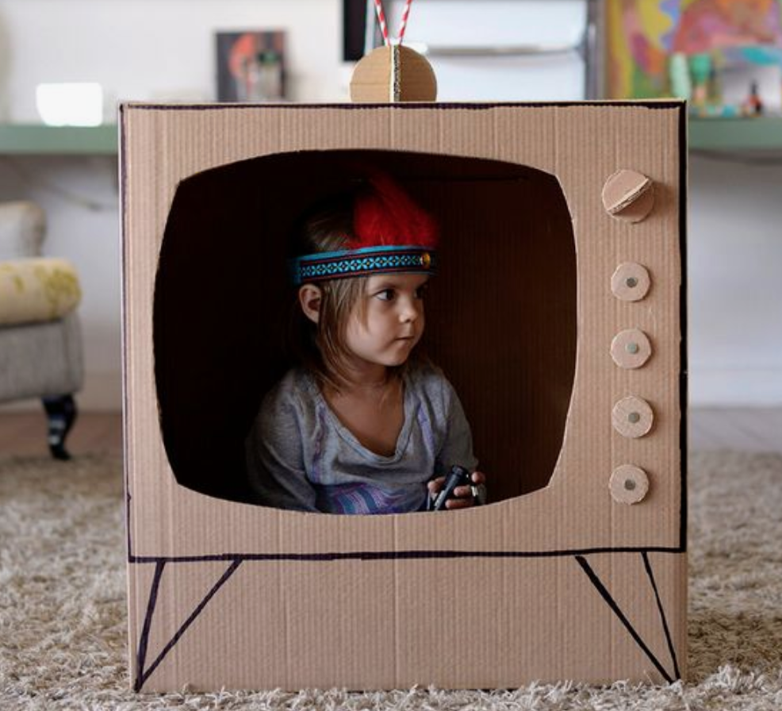

Cardboard is a great material for making Role Play props. With a good pair of scissors and some strong duct tape you can make almost anything including these cars and a television for young stars to perform in.

