Music – Make a Kazoo
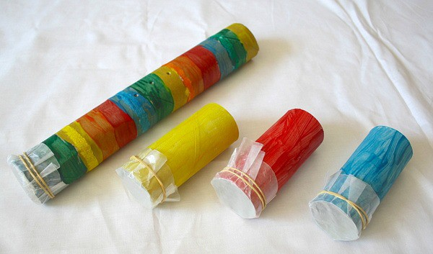

You can make a simple kazoo with a piece of kitchen roll holder, some grease proof paper and elastic bands. Can you use to make your favourite songs to accompany them.

