Art - Rolling Pin Printing
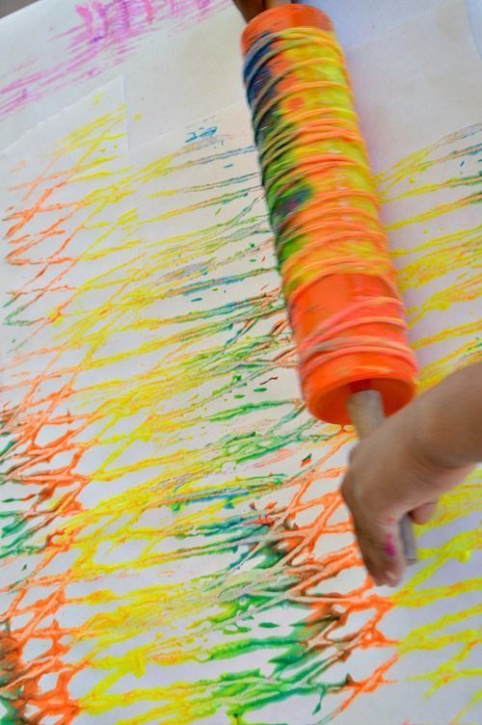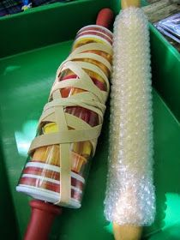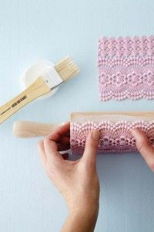
Printing is a great way to explore patterns and colours. You can use a rolling pin as a base and then add textures to it to create interesting prints.

