Art - Cardboard Roll Art
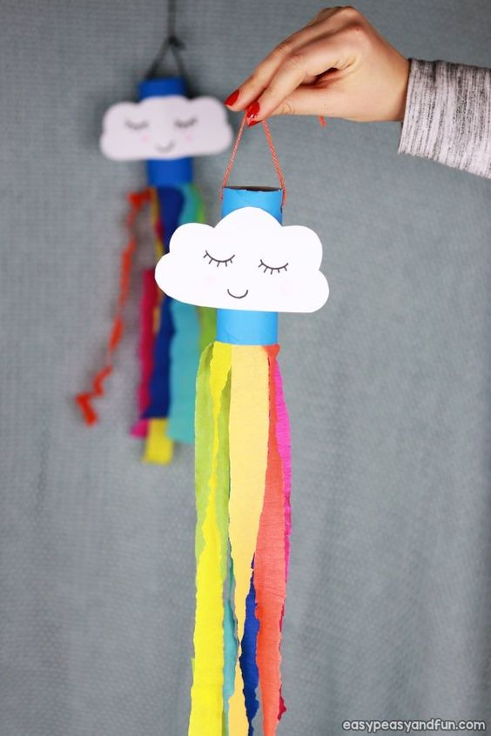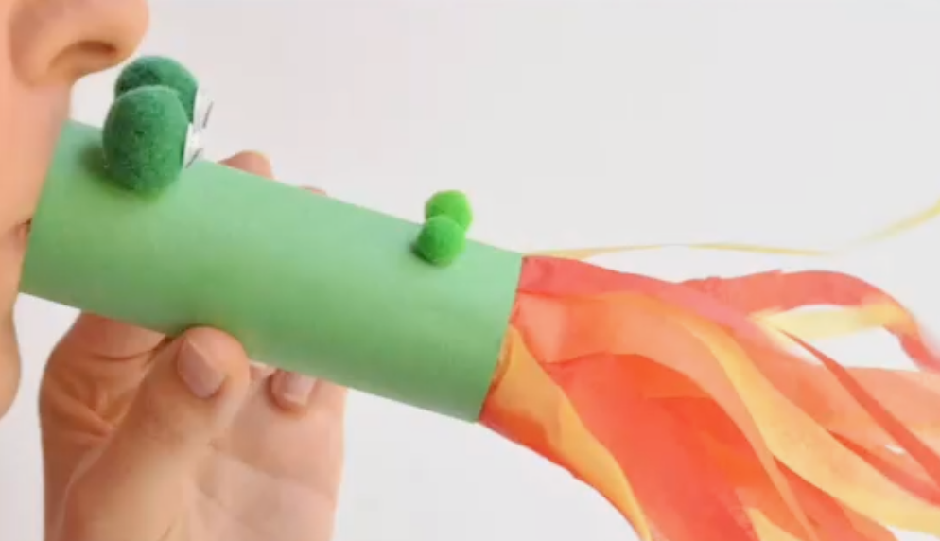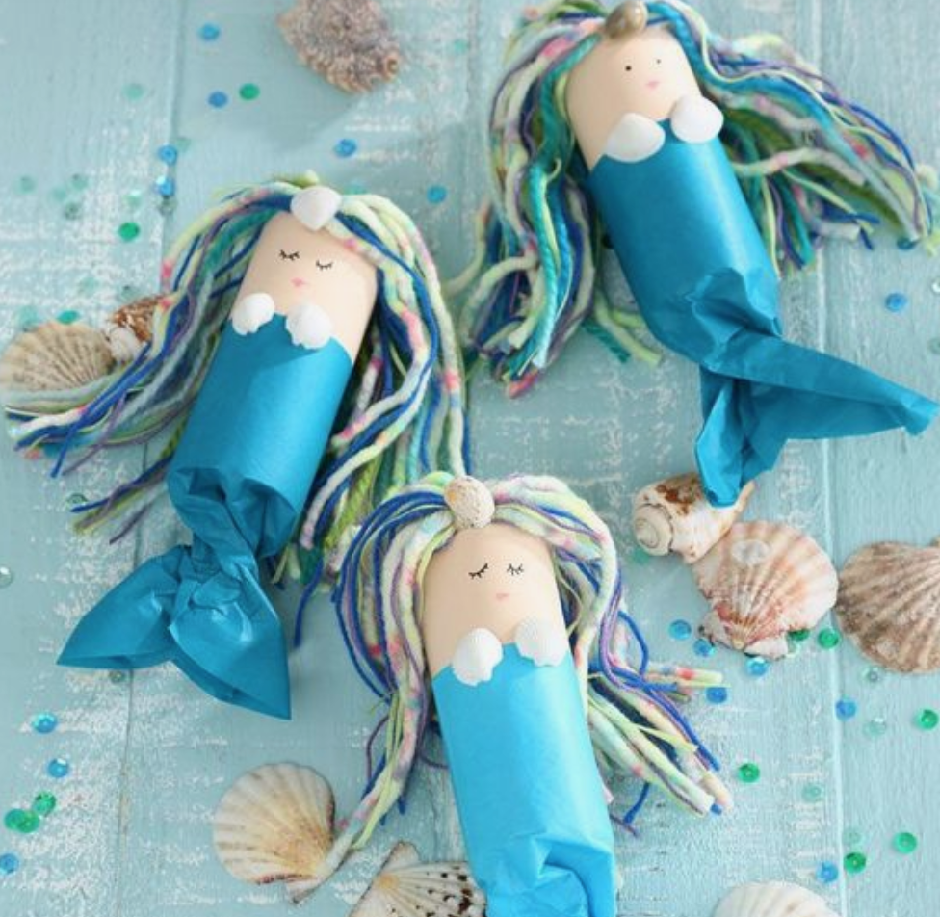

You would surprised at how many things you have in your house that you can turn into art with a little thought. Here are three pretty projects you can make with cardboard tubes.

